Manufacturing Quality Prediction
Group Members:
- Ananya Jha – 25BSR00580
- Devraj Sharma - 25BSR00219
- Habibulla - 25BSR00545
- Ayush Babu - 25BSR00476
- Muddassir Ahmed - 25BSR00237

Problem Statement
In modern manufacturing, undetected defects on the shop floor lead to significant material waste, costly rework, and supply chain delays. The objective of this project is to build an automated, production-ready DataOps and MLOps pipeline that predicts product quality in real time. Using the manufacturing_defects.csv dataset, the system continuously analyzes 16 numerical sensor and process features to predict the DefectStatus of a manufactured unit. By automating the data ingestion, model training, and real-time API serving, this architecture allows quality control teams to proactively identify and isolate defective components before they advance further down the assembly line.

Dataset Description
- The dataset provides insights into factors influencing defect rates in a manufacturing environment. Each record represents various metrics crucial for predicting high or low defect occurrences in production processes.
- It includes production volumes, supply chain quality, quality control assessments, maintenance schedules, inventory management details, workforce productivity metrics, energy consumption patterns, additive manufacturing specifics, and more.
Target Variable
DefectStatus: Predicted defect status.
- Data Type: Binary (0 for Low Defects, 1 for High Defects).

Architecture
DATA SOURCE → DATA INGESTION → DATA VALIDATION / QUALITY → TRANSFORMATION / FEATURE ENGINEERING → MODEL TRAINING → MLFLOW → MODEL VALIDATION → INFERENCE / DEPLOYMENT → MONITORING

Data Ingestion
• Loading the CSV from the shared directory
• Checking the shape of the data (rows, columns)
• Quality Check: Looking for missing values
• Preview the data
• Python library used: Pandas
Code:
import pandas as pd
# 1. Ingestion: Load the CSV from the shared directory
file_path = "manufacturing_defects.csv" # Ensure this matches your exact filename
print(f"Loading data from {file_path}...")
df = pd.read_csv(file_path)
# 2. Basic Validation: Check the shape of the data (rows, columns)
print(f"Dataset successfully loaded. Shape: {df.shape
# 3. Quality Check: Look for missing values
missing_data = df.isnull().sum()
print("\nMissing values per column:")
print(missing_data[missing_data > 0]) # Only prints columns that actually have missing data
# 4. Preview the data
display(df.head())
Output:
Loading data from manufacturing_defects.csv...
Dataset successfully loaded. Shape: (3240, 17)
Missing values per column:
Series([], dtype: int64)

Feature Engineering
• Separate features (X) and target (Y)
• Split into training and testing sets (80% train, 20% test)
• Scale the numerical features
• Python library used: Scikit-learn (sklearn)

Code:
from sklearn.model_selection import train_test_split
from sklearn.preprocessing import StandardScaler
# 1. Separate features (X) and target (y)
X = df.drop('DefectStatus', axis=1)
y = df['DefectStatus']
# 2. Split into training and testing sets (80% train, 20% test)
X_train, X_test, y_train, y_test = train_test_split(X, y, test_size=0.2, random_state=42)
print(f"Training data shape: {X_train.shape}")
print(f"Testing data shape: {X_test.shape}")
# 3. Scale the numerical features
scaler = StandardScaler()
X_train_scaled = scaler.fit_transform(X_train)
X_test_scaled = scaler.transform(X_test)
print("Feature scaling complete.")
Output:
Training data shape: (2592, 16)
Testing data shape: (648, 16)
Feature scaling complete.

Model Training
• Initialize and train the model
• Make predictions on the test set
• Evaluate the model
• Python library used: Scikit-learn (sklearn)
Baseline Model Accuracy
95.52%

Code:
from sklearn.ensemble import RandomForestClassifier
from sklearn.metrics import accuracy_score, classification_report
# 1. Initialize and train the model
model = RandomForestClassifier(n_estimators=100, random_state=42)
model.fit(X_train_scaled, y_train)
# 2. Make predictions on the test set
predictions = model.predict(X_test_scaled)
# 3. Evaluate the model
accuracy = accuracy_score(y_test, predictions)
print(f"Baseline Model Accuracy: {accuracy * 100:.2f}%\n")
print("Classification Report:")
print(classification_report(y_test, predictions))
Output:
Baseline Model Accuracy: 95.52%
Classification Report:
precision recall f1-score support
0 0.93 0.77 0.84 102
1 0.96 0.99 0.97 546

accuracy 0.96 648
macro avg 0.94 0.88 0.91 648
weighted avg 0.95 0.96 0.95 648

MLflow
• Connect to the MLflow tracking server
• Create or set the experiment
• Start the tracking run
• Python library used: Scikit-learn (sklearn) + mlflow

Code:
import mlflow
import mlflow.sklearn
from sklearn.ensemble import RandomForestClassifier
from sklearn.metrics import accuracy_score
# 1. Connect to the MLflow tracking server (running in Docker stack)
mlflow.set_tracking_uri("http://mlflow:5000")
# 2. Create or set the experiment
mlflow.set_experiment("Manufacturing_Defects_Prediction")
# 3. Start the tracking run
with mlflow.start_run():
# Define parameters
n_estimators = 100
random_state = 42
# Log parameters to MLflow
mlflow.log_param("n_estimators", n_estimators)
mlflow.log_param("random_state", random_state)
# Train the model
model = RandomForestClassifier(n_estimators=n_estimators, random_state=random_state)
model.fit(X_train_scaled, y_train)
# Predict and calculate accuracy
predictions = model.predict(X_test_scaled)
accuracy = accuracy_score(y_test, predictions)
# Log the accuracy metric
mlflow.log_metric("accuracy", accuracy)
# Log the model artifact
mlflow.sklearn.log_model(model, "random_forest_model")
print(f"Run successfully logged to MLflow. Accuracy: {accuracy * 100:.2f}%")
Output:
Run successfully logged to MLflow. Accuracy: 95.52%

Model Validation
• Connect to the Mlflow
• Fetch the latest run
• Validate & register
• Python library used: mlflow

Code:
import mlflow
from mlflow.tracking import MlflowClient
# 1. Connect to MLflow
mlflow.set_tracking_uri("http://mlflow:5000")
client = MlflowClient()
experiment = mlflow.get_experiment_by_name("Manufacturing_Defects_Prediction")
# 2. Fetch the latest run
runs = mlflow.search_runs(
experiment_ids=[experiment.experiment_id],
order_by=["start_time DESC"],
max_results=1
)
latest_run_id = runs.iloc[0].run_id
latest_accuracy = runs.iloc[0]["metrics.accuracy"]
print(f"Validating Run ID: {latest_run_id}")
print(f"Model Accuracy: {latest_accuracy * 100:.2f}%\n")
# 3. Validate and Register
THRESHOLD = 0.90
if latest_accuracy >= THRESHOLD:
print(f"Validation Passed! Accuracy is above {THRESHOLD * 100}%.")
# Register the model in MLflow
model_uri = f"runs:/{latest_run_id}/random_forest_model"
model_name = "Manufacturing_Defects_RF_Model"
result = mlflow.register_model(model_uri, model_name)
print(f"Model successfully registered as: {result.name} (Version {result.version})")
# Transition to Staging
client.transition_model_version_stage(
name=model_name,
version=result.version,
stage="Staging"
)
print("Model transitioned to Staging.")
else:
print("Validation Failed. Model accuracy is too low for deployment.")
Output:
Validating Run ID: 123aba162ed8452896e67cf4d03bd8df
Model Accuracy: 95.52%
Validation Passed! Accuracy is above 90.0%.
Model successfully registered as: Manufacturing_Defects_RF_Model (Version 2)
Model transitioned to Staging.

Visualizations and Pipelines
• Airflow DAG: manufacturing_quality_pipeline (Automated ML training pipeline for manufacturing defects)
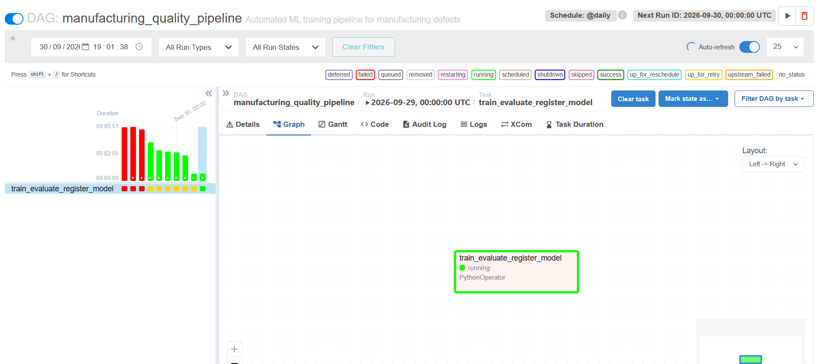

• Inference / Deployment: Predict POST API
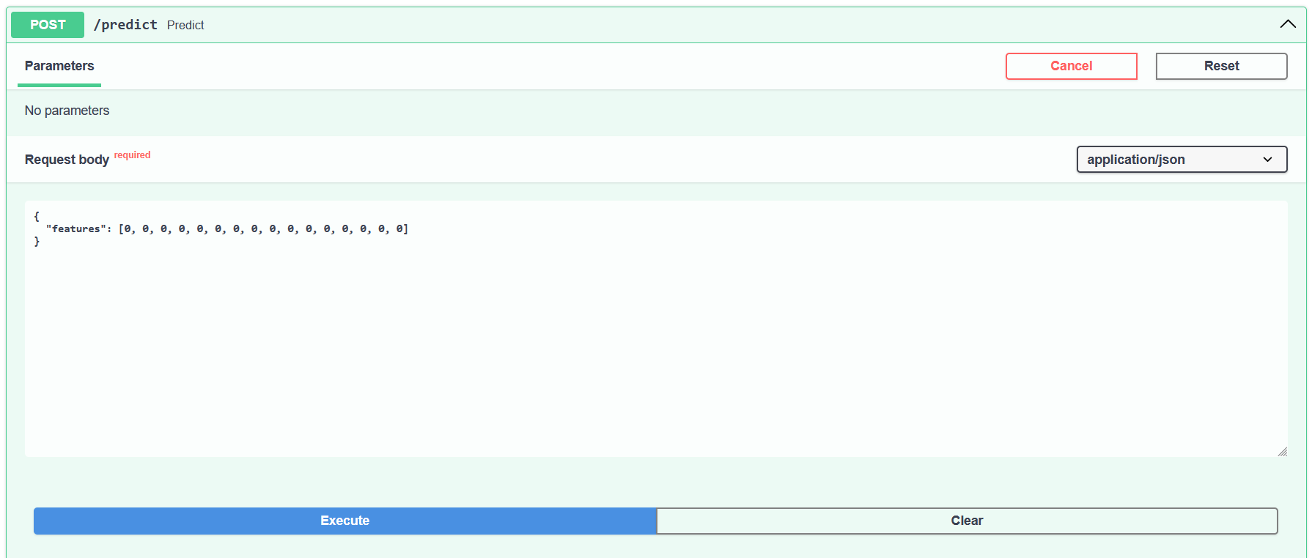
• Grafana visualization:
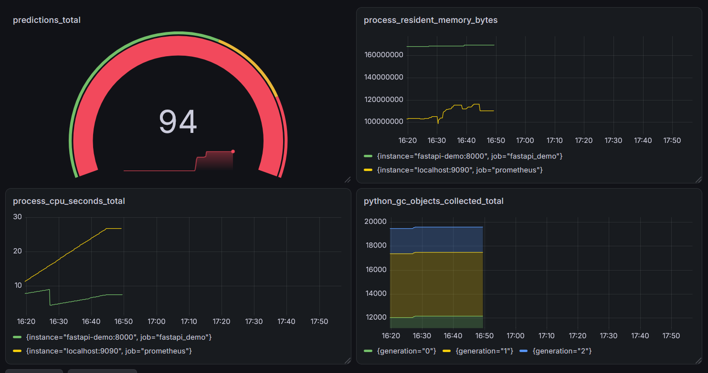
- predictions_total
- process_resident_memory_bytes
- process_cpu_seconds_total
- python_gc_objects_collected_total

Individual Contribution
- Devraj Sharma – Data Ingestion
- Mohammed Habibulla – Feature Engineering
- Ayush Babu – Baseline Model Training
- Muddassir Ahmed – Mlflow + Model Validation
- Ananya Jha – Airflow + Grafana

References
• https://www.kaggle.com/datasets/rabieelkharoua/predicting-manufacturing-defects-dataset
• https://docs.python.org/3/library/index.html
• https://www.guvi.in

